|  |  |  |  |
| --- | --- | --- | --- |
| 1 | | 57,864 | |
| **NUMERO DE FRONTERAS** | | **ENERGIA AGREGADA** | |







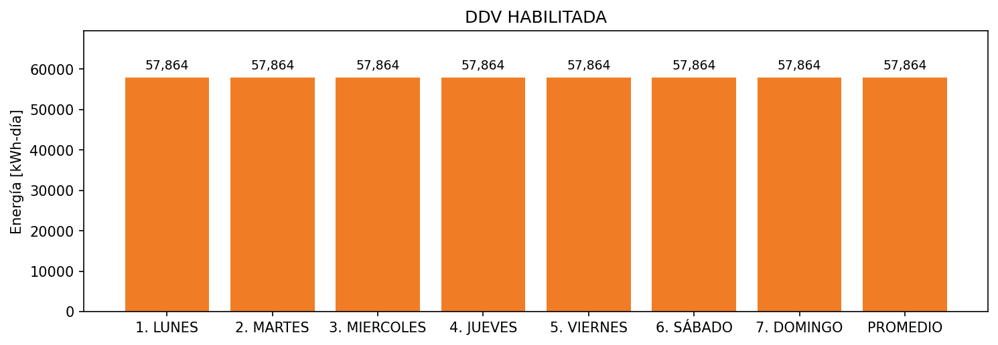

|  |  |  |  |  |  |  |  |  |  |
| --- | --- | --- | --- | --- | --- | --- | --- | --- | --- |
| **FRONTERA** | **COD SIC** | **FRT DDV** | **TIPO DDV** | **PROMEDIO** | **PRÓXIMA ACTUALIZACIÓN** | **MARGEN DE ERROR** | **ÚLTIMA PRUEBA DDV** | **DÍAS PARTICIPACIÓN** | **FECHA REFERENCIA PRÓXIMA PRUEBA DDV** |
| ERROR | ERROR | ERROR | ERROR | ERROR | ERROR | ERROR | ERROR | ERROR | ERROR |